Wesbrook Mall rebuild Phase 2 – Road work
Wesbrook Mall rebuild Phase 2
UBC’s contractor has begun work to rebuild Wesbrook Mall from Agronomy to University Boulevard. This will take about five months (through the summer) and will require road closures of different lanes. The buildings along the route will be notified in advance of any short-term direct impacts to them (including UEL buildings on the east side).
While this construction won’t be as disruptive as the first phase of the Wesbrook Mall rebuild (at University Boulevard / Wesbrook Mall intersection northward), particularly with the lower traffic volumes we are currently experiencing, it is still recommended to avoid the area whenever possible. The northbound section of Wesbrook Mall from University will be open.
- Wesbrook Mall Redesign Phase 2 – We are continuing on with the work we completed last summer to rebuild Wesbrook Mall. This year we will work on the section south of University Boulevard to north of Thunderbird Boulevard. Work will start next Monday, May 4 and will continue through to October 2020 and the work has been split into Stages as shown in the graphic below. We have also created a website with more project background planning.ubc.ca/wesbrook-mall that you may wish to review for more details. The website will be updated throughout construction as more information is known.
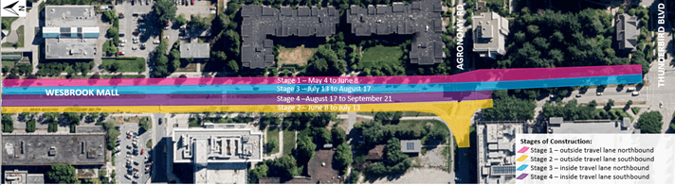
Stages of Construction of Wesbrook Mall Redesign Phase 2:
UBCRoadClosuresMap-Apr2020
The first stage of construction will involve work in the outside northbound lane (east most lane) on Wesbrook Mall. More details of the impacts along Wesbrook Mall during Stage 1 are as follows:

  - Two-way traffic will be maintained along Wesbrook Mall at all times.
  - Bus stops will be temporarily closed within the project scope for safety reasons and will be reopened as soon as possible.
  - The sidewalk along the east side of Wesbrook Mall from Thunderbird Blvd to Agronomy Road will be closed during the first stage of construction from approximately May 18 to June 8. The detour route will be signed.
  - The pedestrian & cyclist crossing across Wesbrook Mall at Agronomy Road as well as at the UBC Hospital will be closed periodically throughout construction. Closures will be minimized.
  - No turning movements will be accommodated to / from Agronomy Road east of Wesbrook Mall.
  - Construction hours are 7:30am to 7pm weekdays and 9am to 5pm Saturdays, though weekend work is not scheduled at this time.
- Pump House – The campus Pump House project got underway in April at the corner of Education Lane and University Boulevard. The most noticeable piece of work is on the north alignment of University Boulevard where utility work is being completed now through to July. All pedestrians and cyclists, service vehicles and emergency vehicles are detoured to the south alignment of University Boulevard while this work is underway. An accessible route on the north alignment is maintained for persons with mobility challenges and the contractors are aware of this need.
- TEF 4 – This project site is on the C2 parking lot on Agronomy Road at Health Sciences Mall. The parking lot is now mostly closed, but work is not yet underway. Once it does get underway in June Health Sciences Mall between Agronomy Road and Thunderbird Blvd will be closed to traffic. Access to parking for TEF 3 is via a new temporary access on Thunderbird Blvd just west of East Mall.
- Pacific Residences – This project has been underway since the end of 2019. A majority of the construction activity is off of Wesbrook Mall and Student Union Boulevard. The sidewalk along Wesbrook Mall is closed for the duration of construction for safety reasons. Detour routes are on Western Parkway in the UEL or west of Walter Gage Residence.

