University Endowment Lands
Record of Electronic
COMMUNITY ADVISORY COUNCIL MEETING
Wednesday, April 13, 2016

Record of the University Endowment Lands (UEL) Community Advisory Council electronic meeting of Wednesday, April 13, 2016. This was an electronic meeting with review and recommendation of CAC and APD Council Replacement for Area D by email completed on April 13, 2016. The electronic format of the meeting was initiated by the CAC President, Dave Forsyth, and agreed by all council members, in order to ensure timely replacement with the formerly resigned CAC/ADP member, Jean-François Caron.

CAC Members Present:
Dave Forsyth, Area A, President
Jaymie Ho, Area B, Vice-President
Peter McConnell, Area C, Secretary-Treasurer
Lynne Pomfret, Area A
Hong Chen, Area D
Mojan Nozari, Area D

- The CAC council waives the notice period for calling a meeting and approves a meeting by email.

- The CAC accepts the resignation of Jean-François Caron from the Community Advisory Council and Advisory Design Panel in the January CAC meeting. The CAC thanks Jean-François Caron for his service to the community.

Result of This Electronic CAC Meeting:

All members of the CAC vote in the affirmative with both candidates.

RECOMMENDATION:

Moved, Seconded and Carried.

That the CAC Advisory Council Panel recommend that Justin LeBlanc be approved as a CAC representative for Area D.

That the CAC Advisory Council Panel recommend that Kent Mullinix be approved as an ADP representative for Area D.
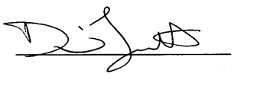
Dave Forsyth,
President,
Community Advisory Council

